05/04/2024

Portfolio Assignment for Excel and Tableau

Aaron Green

Contents

Part 1 – Policies and Procedures 2

General Data Protection Regulation 2

Data Protection Act 2018 2

Why It Is Important to Be Aware of These Rules? 2

Part 2 - Excel 3

Password Protection 3

Change Currency to £ 3

Create Table 4

Filter for 2019 4

Create Chart from Table 4

Filter Top 20 Rank Countries 5

Colour Background 6

Macros 6

Header & Footer 8

Part 3 – Tableau 8

Data & Relationships 8

Worksheets 9

Dashboard 11

Part 4 – The Reflective 11

## Part 1 – Policies and Procedures

### General Data Protection Regulation

General Data Protection Regulation (GDPR) is a data protection law passed by the European Union (EU). It applies to anyone physically in the EU or the European Economic Area (EEA) and to businesses that are in the EU/EEA or handle data of people in the EU/EEA.

For the individual, this law allows the induvial the right to decide how their personal information gets processed which can involve accessing, correcting, amending, restricting, and deleting their personal information.

For businesses, they must transparently explain the data collection in a privacy policy, the legal basis and purpose for each data processing category and implement measures to securely store data to prevent breaches.

GDPR has 7 principles:

1. Lawfulness, fairness, and transparency
2. Purpose limitation
3. Data minimization
4. Accuracy
5. Storage limitation
6. Integrity and confidentiality (aka, security)
7. Accountability

### Data Protection Act 2018

The Data Protection Act 2018 is legislation in the UK that governs how personal data is handled. It was introduced to update and strengthen data protection laws in line with the GDPR, which came into effect in the European Union in 2018.

The Data Protection Act outlines rules and regulations regarding the processing, storage, and sharing of personal data. It gives individuals more control over their personal information and requires organizations to handle data responsibly and securely. The Act also sets out the rights of individuals in relation to their personal data and establishes penalties for organizations that fail to comply with its provisions.

### Why It Is Important to Be Aware of These Rules?

GDPR and the DPA are legal requirements, and failure to meet these requirements will in severe penalties, including fines and legal action for both the individual and company at fault. As a data analyst, you are likely to deal with personal data in your work, and you must ensure that you handle it in compliance with these regulations.

Compliance with GDPR and the DPA helps build trust with customers, clients, and stakeholders. By demonstrating that you handle personal data responsibly and ethically, you can enhance your organization's reputation and credibility.

## Part 2 - Excel

### Password Protection

To protect a workbook with a password, I went to **File > Info > Protect Workbook > Encrypt with Password**. Then I entered a password, for example my password was, "123". I re-entered the password and clicked OK.

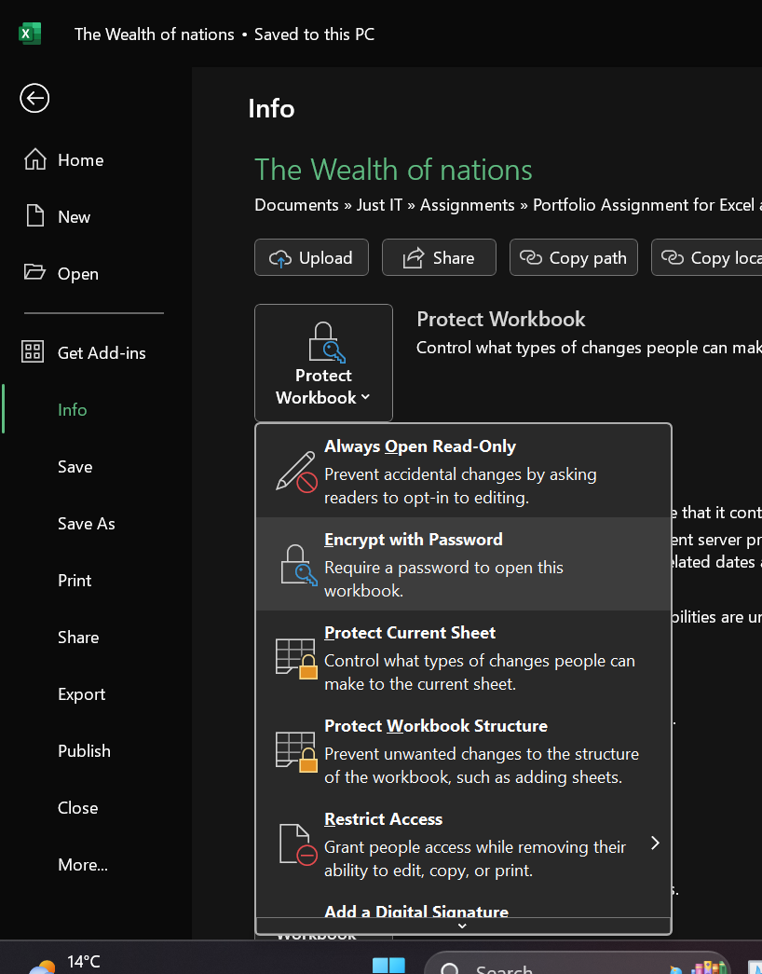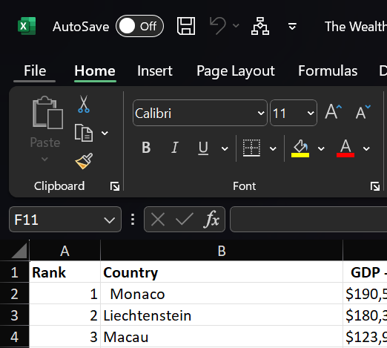

### Change Currency to £

To change a column or cell to £, I highlighted the right area, then clicked the dropdown in the number area and chose currency. I could also change the type of currency in the accounting number format option.

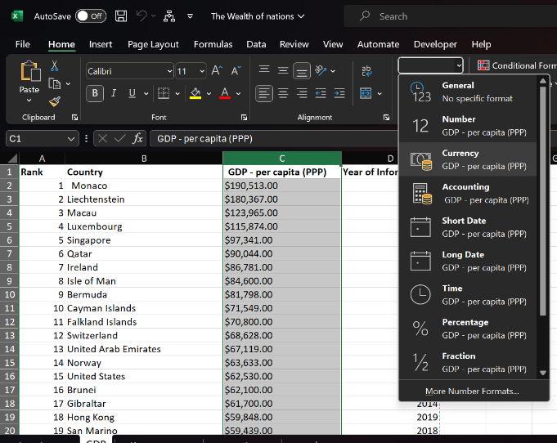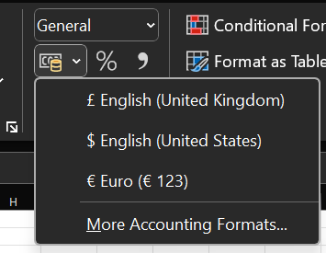

### Create Table

To create a table, I highlighted the area with the data I wanted to make a table from, then went to the insert tab and clicked on table. I pressed OK on the create table window.

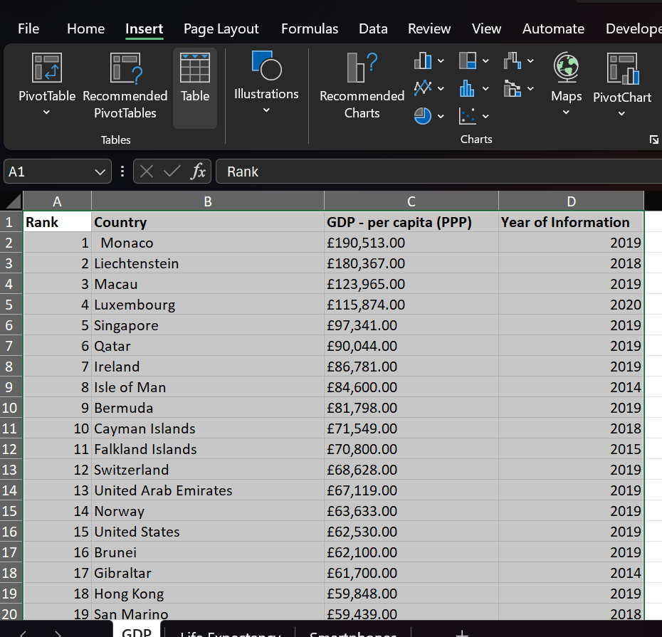

### Filter for 2019

I pressed the filter icon on the ’Year of Information’ and deselected all years except 2019

­­

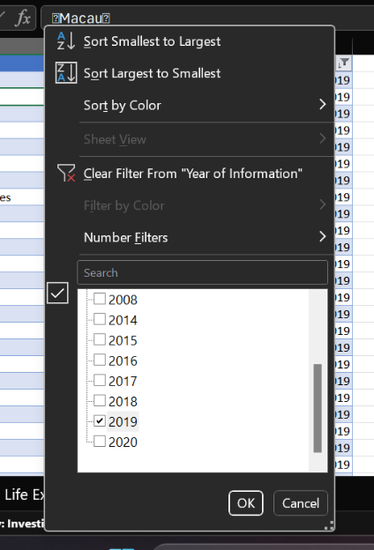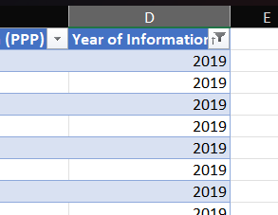

### Create Chart from Table

I highlighted the rank, country, and GDP columns. From the insert tab, I went to the ‘Charts’ section and selected ‘Insert Column or Bar Chart’ where I chose the ‘Clustered Bar Chart.

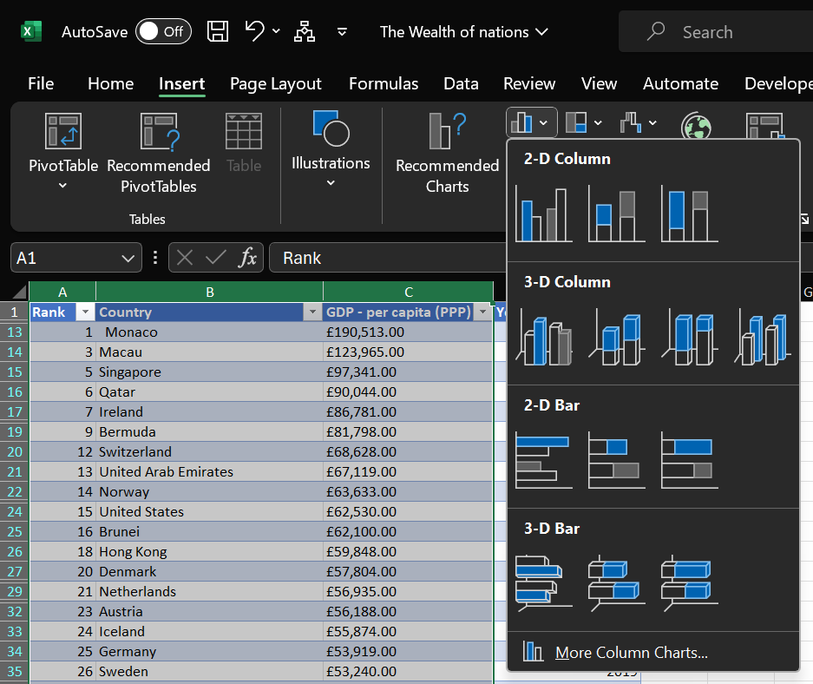

### Filter Top 20 Rank Countries

I clicked the drop-down filter of GDP **- per capita (PPP)** **> Number Filters > Top 10.** Then I typed in 20 into the middle section and clicked OK.

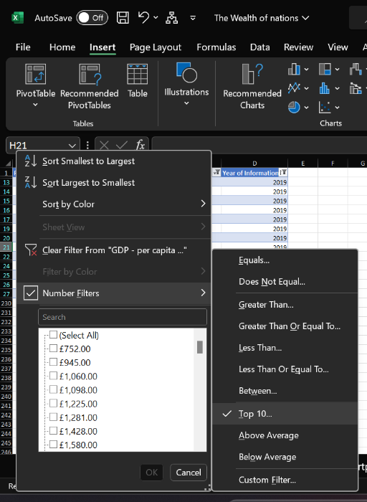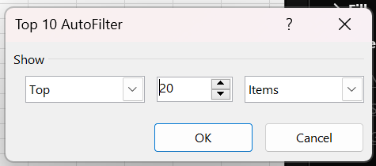

I then added in the axes titles and named them accordingly as well as titling the chart.

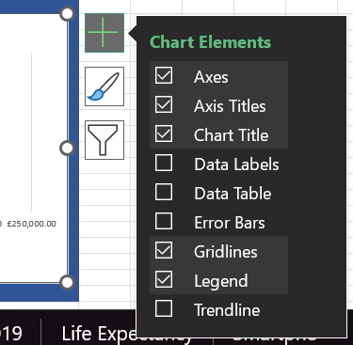

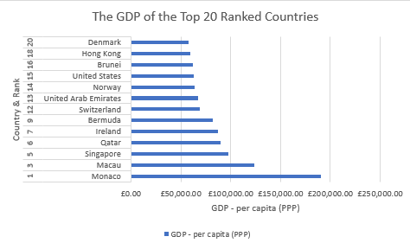

### Colour Background

I highlighted the area behind the chart and used the fill to colour the area blue.

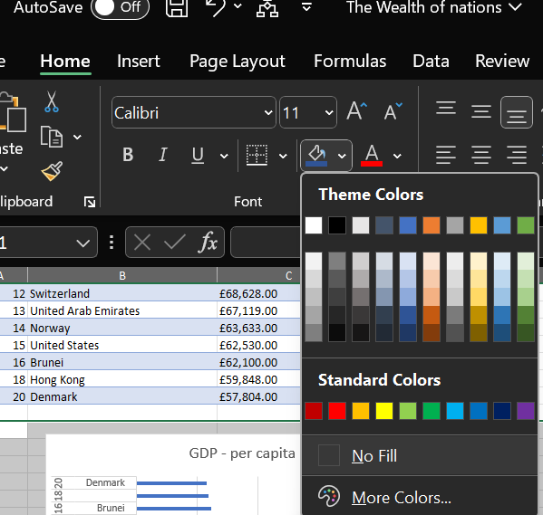

### Macros

To create the macros, I went to the Developers tab and clicked the ‘Record Macro’ button. I named the first copy, then clicked OK. I then selected the whole page before I right clicked and copied it. After that I hit ‘Stop Recording’. I used the same method for recording the save and print macros.

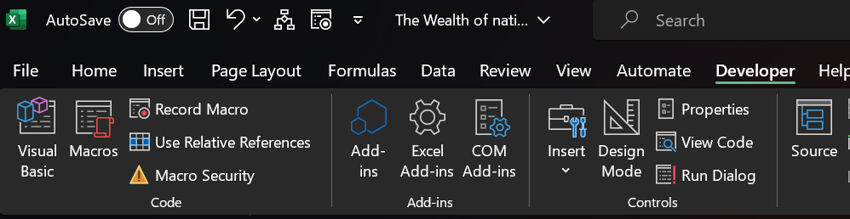

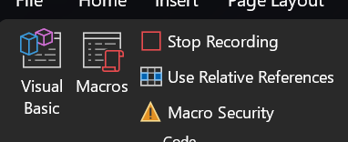

I used the ‘Copy’ macro to copy the Excel page and pasted it below.

|  |  |  |  |
| --- | --- | --- | --- |
| **Rank** | **Country** | **GDP - per capita (PPP)** | **Year of Information** |
| 1 | Monaco | £190,513.00 | 2019 |
| 3 | Macau | £123,965.00 | 2019 |
| 5 | Singapore | £97,341.00 | 2019 |
| 6 | Qatar | £90,044.00 | 2019 |
| 7 | Ireland | £86,781.00 | 2019 |
| 9 | Bermuda | £81,798.00 | 2019 |
| 12 | Switzerland | £68,628.00 | 2019 |
| 13 | United Arab Emirates | £67,119.00 | 2019 |
| 14 | Norway | £63,633.00 | 2019 |
| 15 | United States | £62,530.00 | 2019 |
| 16 | Brunei | £62,100.00 | 2019 |
| 18 | Hong Kong | £59,848.00 | 2019 |
| 20 | Denmark | £57,804.00 | 2019 |
|  |  |  |  |
| |  | | --- | |  | |  |  |  |
|  |  |  |  |
|  |  |  |  |
|  |  |  |  |
|  |  |  |  |
|  |  |  |  |
|  |  |  |  |
|  |  |  |  |
|  |  |  |  |
|  |  |  |  |
|  |  |  |  |
|  |  |  |  |
|  |  |  |  |
|  |  |  |  |
|  |  |  |  |
|  |  |  |  |
|  |  |  |  |
|  |  |  |  |
|  |  |  |  |
|  |  |  |  |
| **Copy**  **Print**   |  | | --- | |  | |  |  |  |
|  |  |  |  |
|  |  |  |  |
|  |  |  |  |
|  |  |  |  |
|  |  |  |  |
|  |  |  |  |

### Header & Footer

I went to the View tab and in the Workbook Views section chose ‘Page Layout’, where I added my name and group to the header as well as the date, assignment and subject to the footer.

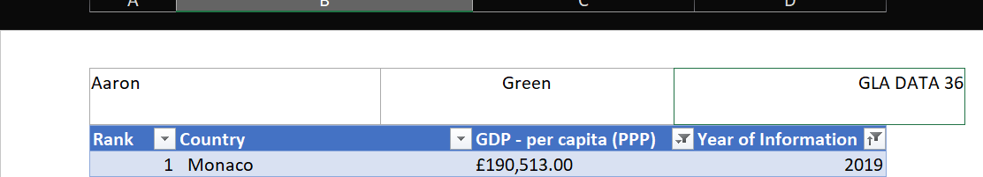

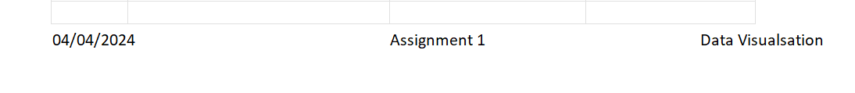

## Part 3 – Tableau

### Data & Relationships

I imported the Wealth of Nations file into Tableau.

I added the sheets of the excel file and created relationships between the country fields of each table.

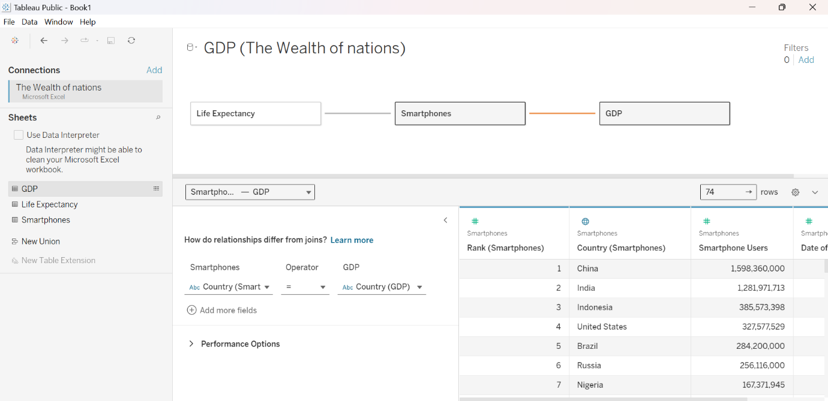

I also checked the data types of each column to make sure they were correct.

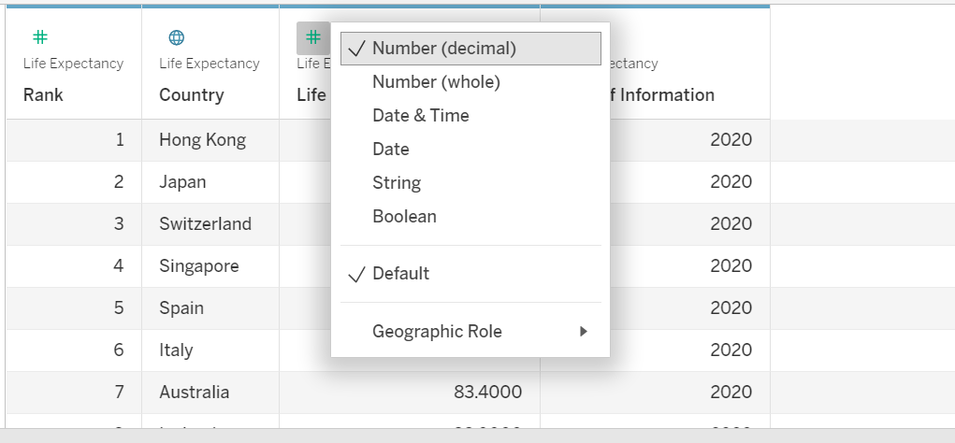

### Worksheets

For the bar chart I displayed the life expectancy of each country while filtering to only show the top 20 ranked countries.

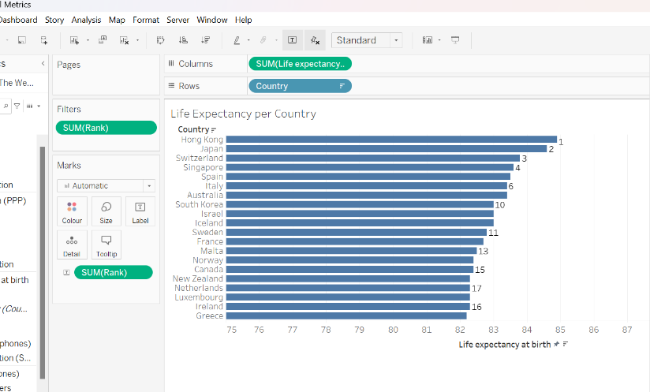

For the map chart I decided to make the colour easier for colour-blindness by using blue but using lighter blue for lower amounts of smartphone users and darker blue for higher amounts. This also filters for the top 20 ranked countries.

For the scatter graph, I measured the life expectancy against the GDP, labelling each point with the country and only showing the top 20 countries

For the pie chart I created it to show the distribution of smartphone users. I kept the blue to keep the colour scheme consistent. I added an alternating pattern of blue and grey to keep it easy to see for people with colour-blindness and added a white border to segment each part a bit more. This is also filtered for the top 20 countries.

### Dashboard

I created a dashboard and then added the worksheets to bring it all together.

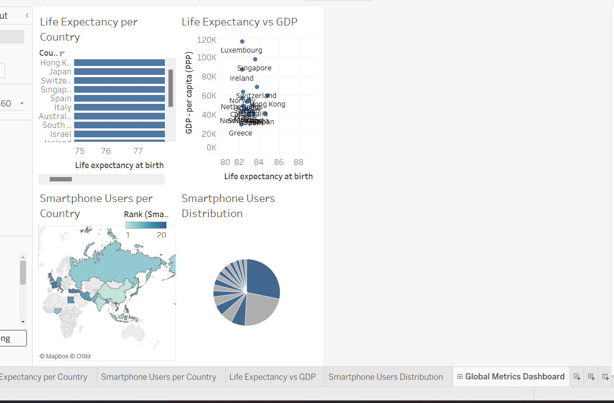

## Part 4 – The Reflective

I think I have successfully achieved my goals of explaining the policies and procedures that a data analyst in the UK must follow and formatting the 'Wealth of Nations' dataset correctly and presenting the data in a Tableau dashboard.

Although the project was successful overall, I believe some areas that could be improved. For example, I could have mentioned changes that occurred due to changes to GDPR as Britain left the EU. Additionally, I think I could have created more visually appealing Tableau graphs while maintaining a colour-blind friendly colour scheme.

Despite these shortcomings, I believe that the project demonstrated the importance of data visualization in effectively communicating complex information in an accessible and clear manner.